**SPANISH TRANSITION REVIEW: LEVEL 2 - 3**

At the completion of Spanish 2, I should be able to successfully:

* Introduce myself and others and describe with adjectives
* Talk about foods I enjoy and how to prepare them
* Discuss where I shop and what I buy
* Talk about the past and I can explain when to use the ***preterite*** and when to use the ***imperfect*** tense
* Go the doctor and describe my illness
* Discuss travel and leisure activities
* Use the verbs ***ser*** and ***estar*** correctly
* Use the verbs ***saber*** and ***conocer*** correctly

**VOCABULARIO**

Sort the words in the box according to the categories listed.

|  |
| --- |
| la corbata las fresas la biblioteca la nariz el bombero  la joyería la espalda el impermeable el traje las zapatillas  la rodilla el mecánico la peluquería los aseos la cebolla  el socorrista la farmacia el arquitecto el abrigo la librería  la papelería el cantante los camarones la cabeza el gimnasio  la sandía el brazo la mantequilla el aula el laboratorio |

**LA COMIDA LA ROPA EL CUERPO**

1. _________________ 1. _________________ 1. _________________
2. _________________ 2. _________________ 2. _________________
3. _________________ 3. _________________ 3. _________________
4. _________________ 4. _________________ 4. _________________
5. _________________ 5. _________________ 5. _________________

**LAS TIENDAS LA ESCUELA LAS PROFESIONES**

1 _________________ 1. _________________ 1. __________________

2. _________________ 2. _________________ 2. __________________

3. _________________ 3. _________________ 3. __________________

4. _________________ 4. _________________ 4. __________________

5._________________ 5. _________________ 5. __________________

**UNDIAD PREIMINAR**

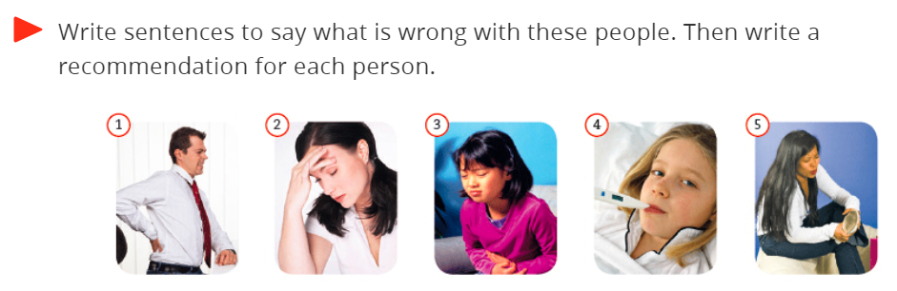

1. __________________________________________________________________________________
2. __________________________________________________________________________________
3. __________________________________________________________________________________
4. __________________________________________________________________________________
5. __________________________________________________________________________________

**UNIDAD 3**

*Completa**las oraciones con la palabra correcta.*

Me gusta este poncho de (**lana / talla**) **1**. **__________________** porque es muy (**cómodo / incómodo**) **2**. **__________________** Tiene (**colores / sabores**) **3**. **__________________** claros y oscuros. También me gustan esas botas de (**caro / cuero**) **4**. **__________________** y aquella falda de (**lunares / collares**) **5**. **__________________.** Las botas me (**queda / quedan**)

**6. __________________** muy bien.

***Lee y elige****.*

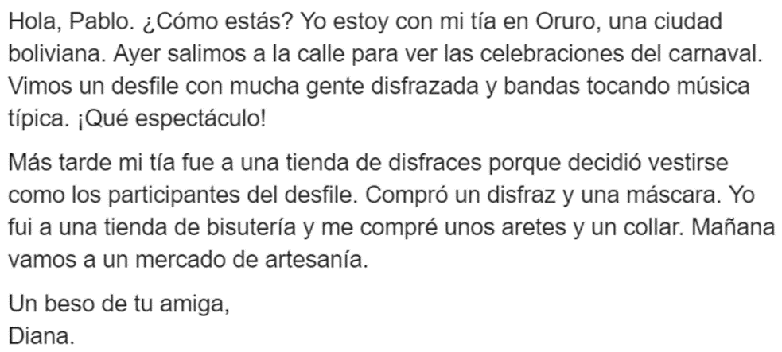*Read the paragraph and choose* ***C*** *(*cierto*) or* ***F*** *(*falso*) for the following statements.*

1. **C F** Diana y su tía hicieron un viaje a una ciudad mexicana.
2. **C F** Ayer ellas se quedaron *(stayed)* en casa.
3. **C F** En el desfile *(parade)* participó poca gente.
4. **C F** Diana fue a un quiosco a comprar unos aretes y un collar.
5. **C F** Diana y Rita fueron ayer a comprar comida al mercado.

**UNIDAD 4**

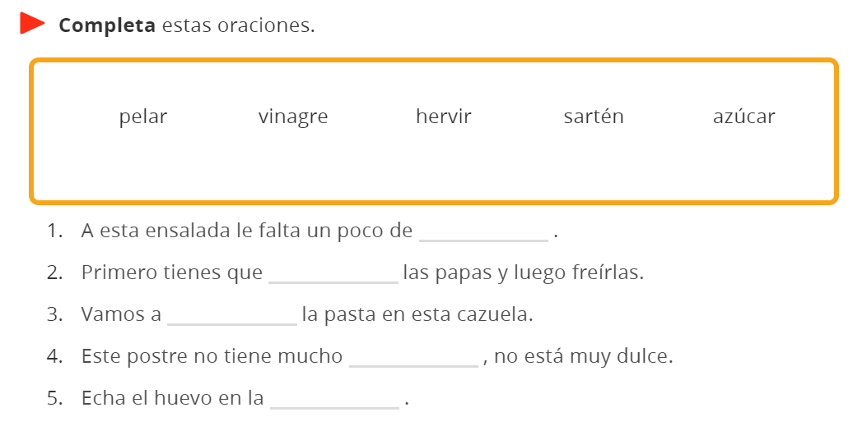

**UNIDAD 7**

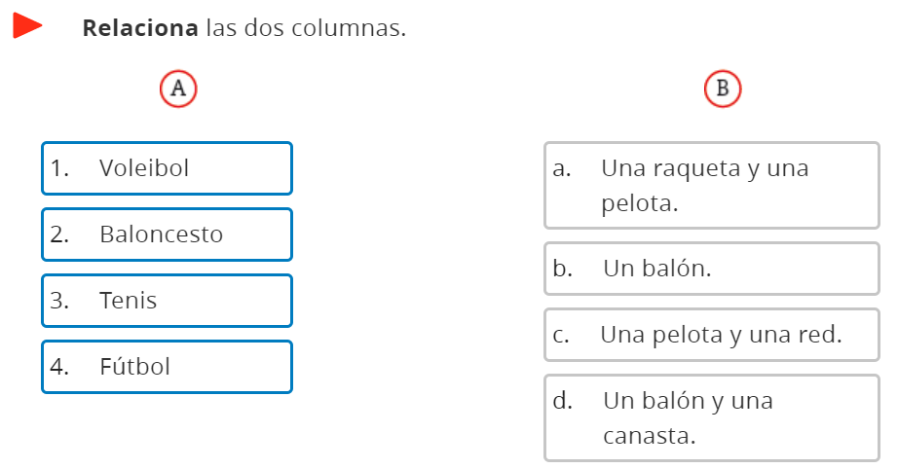

**GRAMÁTICA**

**EL PRETÉRITO (Simple Past Tense)**

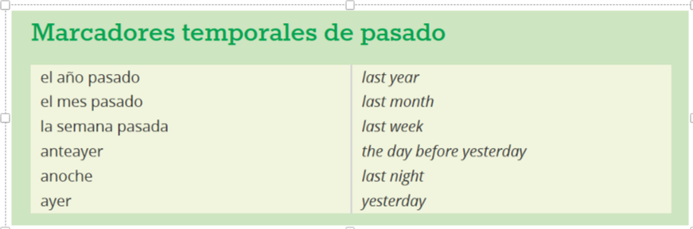

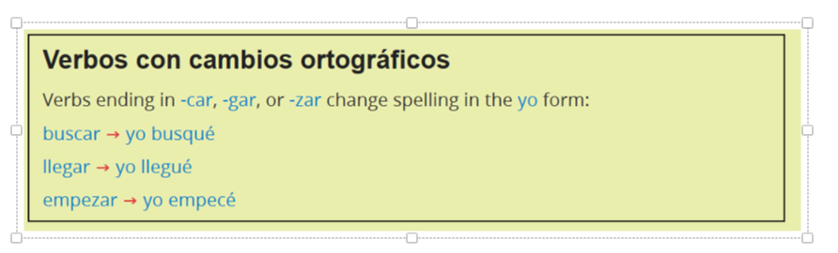

**PRETERITE CONJUGATIONS FOR REGULAR -AR, -ER & -IR VERBS**

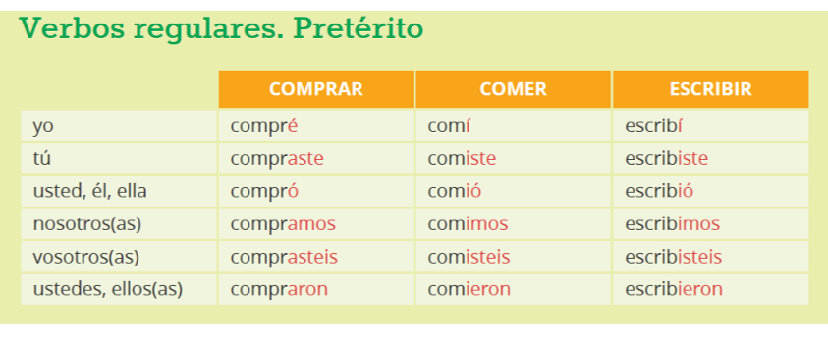

**PRETERITE -CAR, -GAR & -ZAR VERBS**

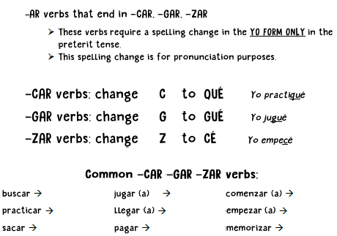



***¿Cómo se dice?***

1. I played (to**car**)

2. I paid (pa**gar**)

3. I started (almor**zar**)

**PRETERITE IRREGULAR VERBS**

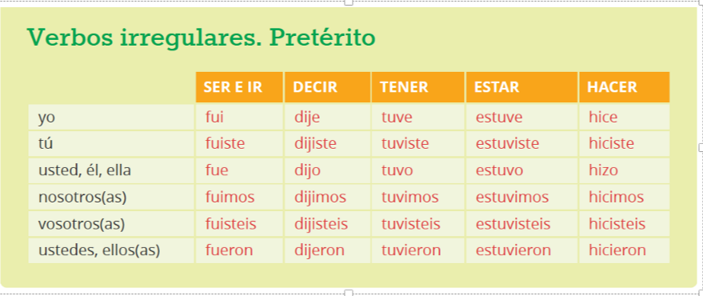

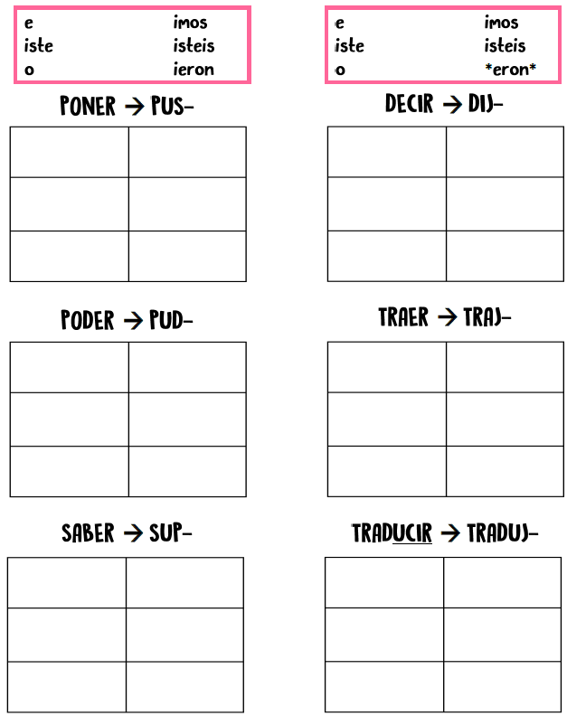

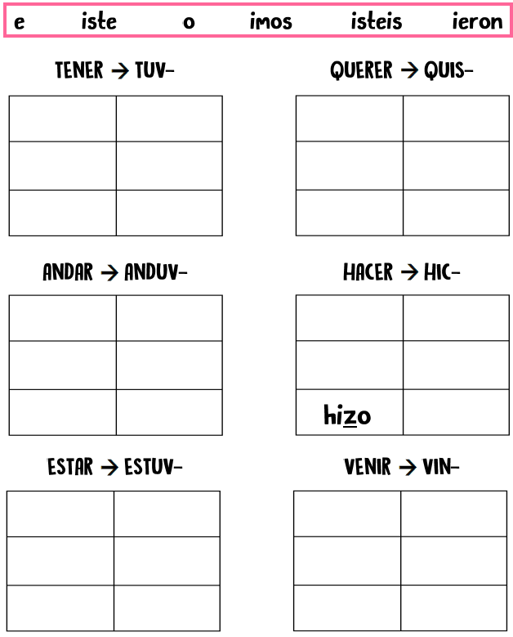

**EL IMPERFECTO (the ongoing past tense)**

|  |  |  |  |  |
| --- | --- | --- | --- | --- |
| **AR** | **ER/IR** | **SER** | **IR** | **VER** |
| -aba | -ía | era | iba | veía |
| -abas | -ías | eras | ibas | veías |
| -aba | -ía | era | iba | veía |
| -ábamos | -íamos | éramos | íbamos | veíamos |
| -abais | -íais | erais | ibais | veíais |
| -aban | -ían | eran | iban | veían |

**MODELO: *When I was 8 years old, I used to ride horses.***

***Cuando yo tenía ocho años, yo montaba a caballos.***

1. I / 10 years old / collect coins

_________________________________________________________

1. We / 5 years old / draw

_________________________________________________________

1. Pablo / 12 years old / play chess

_________________________________________________________

1. Ellos / 6 years old / drink milk

_________________________________________________________

1. You / 9 years old / ride a skateboard

_________________________________________________________

1. Sofía / 3 years old / run

_________________________________________________________

1. I / 8 years old / to have a picnic

_________________________________________________________

1. You / 4 years old / to play cards

_________________________________________________________

1. We / 10 years old / eat

_________________________________________________________

1. She / 13 years old / go*** the movies

_________________________________________________________

**DIRECT OBJECTS & PRONOUNS**

*Underline the* ***DIRECT OBJECT*** *in each of the following sentences.*

**MODELO: *Yo como las verduras.***

|  |  |
| --- | --- |
| me (me) | nos (us) |
| te (you) | os (you all) |
| lo (it, you, him)  la (it, you, her) | los (them, you all)  las (them, you all) |

1. Ella corta la manzana.
2. Los muchachos leen los libros.
3. El perro bebe el agua.
4. Nosotros vemos a nuestras tías

*Now rewrite the sentences above by* ***REPLACING*** *the direct object with the* ***DIRECT OBJECT PRONOUN****.*

**MODELO: *Yo las como. (Yo como las verduras.)***



**INDIRECT OBJECTS & PRONOUNS**

*Write the Indirect Object Pronoun that would* ***REPLACE*** *the following people.*

1. ___________ a mi madre 6. ___________ a mí
2. ___________ a los profesores 7. ___________ a Marta
3. ___________a nosotros 8. ___________ a vosotros
4. ___________ a ti 9. ___________ a él
5. ___________ a ustedes 10. ___________ a ti y a mí

|  |  |
| --- | --- |
| me (to/for me) | nos (to/for us) |
| te (to/for you) | os (to/for you all) |
| le  (to/for him,her) | les  (to/for them, you all) |

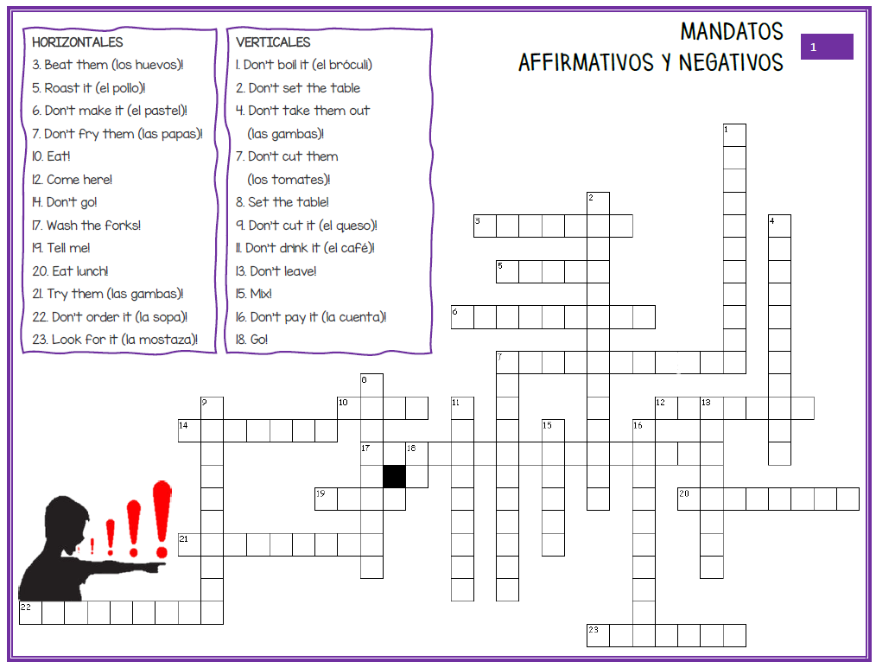**POSITIVE & NEGATIVE TÚ COMMANDS with DIRECT OBJECT PRONOUNS**